**WAREHOUSE INVENTORY MANAGEMENT (WIM)**

**REPORTS**

Reports field is used to maintain the stock reports. This Reports field will show all the products in monthly wise reports, Stock reports, shipment wise reports.

**WHY THIS TOOL:**

The Reports field is helpful for **WAREHOUSE** Department to maintain and manage the WAREHOUSE Stock. By using this tool, they will update the stock details like PROACTIVE and REACTIVE to SIR.

**HOW TO USE THIS TOOL:**

**STOCK REPORTS:**

**Step-1:-** Open WIM and click on Reports field in menu and select Stock Reports.

**Step-2:-** Show all button will produces all the data about the products which are in our WAREHOUSE (PROACTIVE).

**Step-3:-** Vizag button will produces products data which are in Vizag and Hyderabad button will produces products data which are in HyderabadHyH.

**Step-4:-** We can download this data using download data button.

**SHIP WISE REPORTS:**

**Step-1:-**Select theShip code then it will produces the Shipment Wise Records.

**Step-2:-** The Dynamic Stock table represents the overall stock that is PROACTIVE and REACTIVE in that particular Shipment.

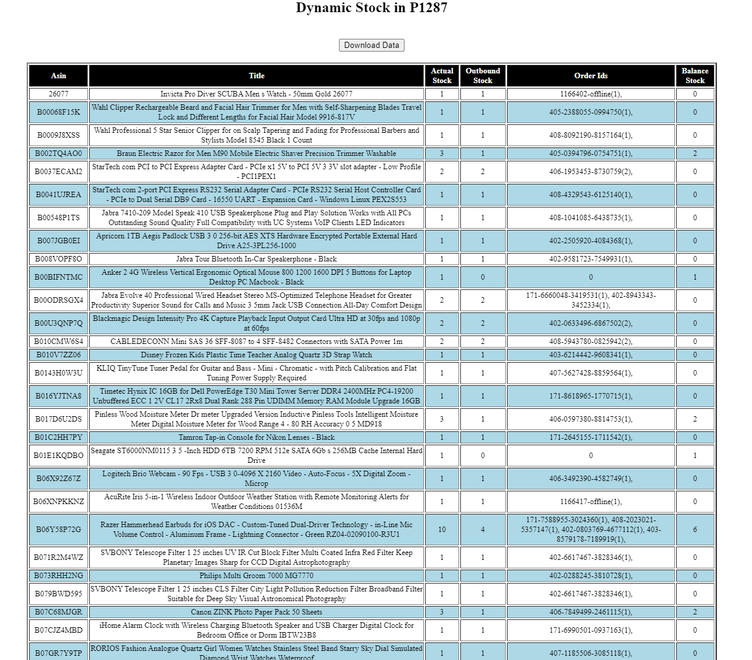

**Step-3:-** The Unused Stock table represents the PROACTIVE Stock that is the left over stock after outbound in that particular Shipment.

**Step-4:-** The middle table represents all the shipment data with PUIDs. The PUIDs are used to distinguish the products with Same **ASIN,** So that it is easy for **FULFILMENT** Department to know which product got returned.

**Step-5:-** The Shipment products are REACTIVE by Default and They use **convert the balance stock to Proactive** button to Convert the remaining products after outbound to Proactive.

**DATE WISE REPORTS:**

**Step-1:-** Enter the start date and the end date and click submit button.

**Step-2:-** It will produces the date wise reports.

**DATE REPORTS:**

**Step-1:-** Enter the start date and the end date and click submit button.

**HISTORY**

History is used to know what the updates or actions are done in the WIM at what time and how has done that action.

**WHY THIS TOOL:**

This tool is helpful for FULFILMENT Department to know daily updates and history.

**HOW TO USE THIS TOOL:**

**Step-1:-**Open WIM click on History in Menu and it will produces all the log data.

**Step-2:-**

**UPLOADS**

Uploads field is used to upload the shipment data. In that field contains Manual(single), New Data (Bulk) and Edit old (Bulk).

**WHY THIS TOOL:**

Uploads field is used to upload the shipment data. In that field contains Manual(single), New Data (Bulk) and Edit old (Bulk).

**HOW TO USE THIS TOOL:**

**Manual(single):**

**Step-1:-**In this field, we need to fill the form to enter a single product.

**BARCODES**

BARCODES field is used to print the barcodes using PUID. To label the products.

**WHY THIS TOOL:**

This tool is helpful for­­­ **FULFILLMENT** Department to distinguish the products using these barcodes and easy to Restock the products.

**HOW TO USE THIS TOOL:**

**Step-1:-** Open WIM and click on Barcodes field in menu and select Generate Barcodes.

**Step-2:-** Enter PUIDs that you want to generate barcodes.

**Step-3:-** Generate the barcodes using Generate Barcodes button.

**Step-4:-**Download the barcodes Using Download Reports Button.

**Step-5:-** They will stick these barcodes to the products.

